1. 题目

Early Prediction of Disease Onset Based on Longitudinal Electronic Health Records

2.代表性图片

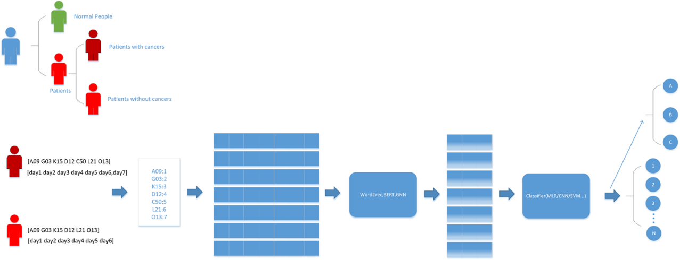

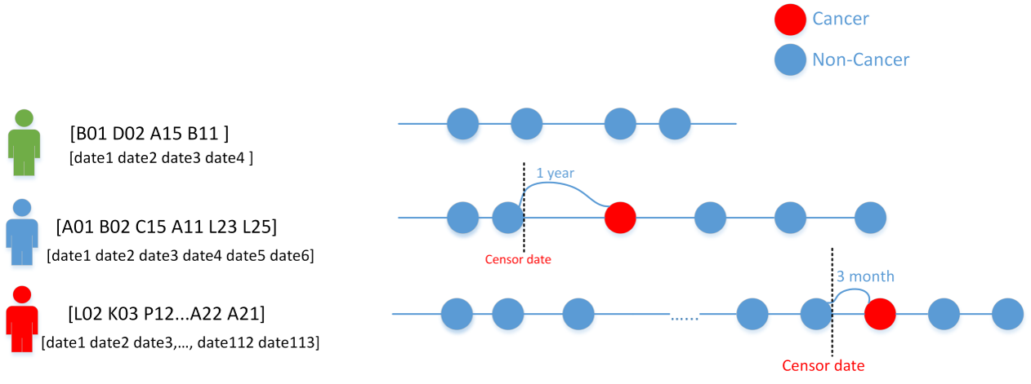

3.具体内容

Breast cancer stands as a formidable challenge to women's health, compounded by the current absence of an effective treatment. This underscores the pivotal role of early detection and diagnosis in mitigating the risk of mortality. Over the past few decades, an array of enhancement techniques, including X-rays (mammography), ultrasound, and magnetic resonance imaging (MRI), has been deployed to offer intricate insights into mammogram images, streamlining the detection of breast cancer. While these methods excel in screening for breast tumors, they fall short in monitoring patients' diverse stages and grapple with the challenges of predicting diseases in advance.

Moreover, a comprehensive understanding of breast cancer's etiology remains elusive. Acknowledging the human body as a complex, interconnected system, where the various states of organs mirror similar diseases in patients, underscores the imperative to leverage the diverse states and developments of different body parts for predicting breast cancer. The widespread implementation of the electronic health record (EHR) system, storing extensive medical data across different periods, provides a significant opportunity for achieving early prediction of breast cancer. Through the utilization of large-scale longitudinal health records, this project aims to develop an early prediction system for breast cancer, delving deeper into unraveling the evolving patterns of this complex disease.